Running Result
Server
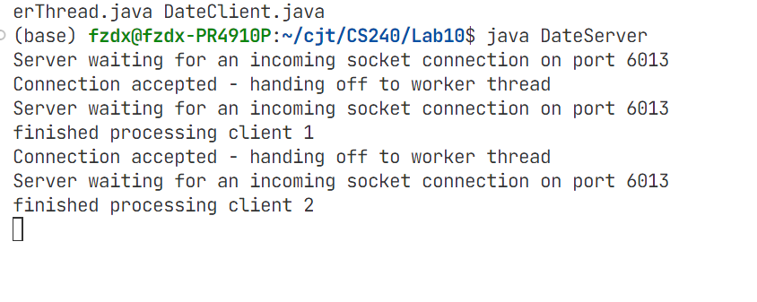
Client
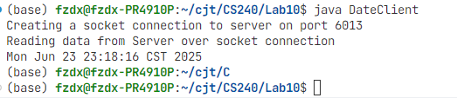

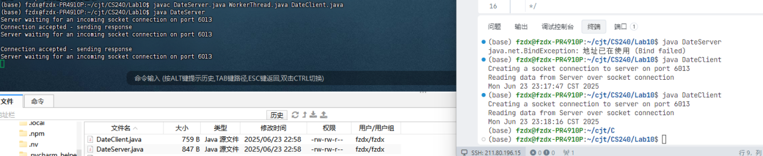

Code

import java.net.*;
import java.io.*;

/**
* WorkerThread is responsible for handling a single client connection.
* Each client connection will have its own WorkerThread instance.
*/
public class WorkerThread extends Thread {
private Socket clientSocket;
private int clientNumber;

/**
* Constructor.
* @param socket The client's connection socket.
* @param clientNumber The sequential number of the client.
*/
public WorkerThread(Socket socket, int clientNumber) {
this.clientSocket = socket;
this.clientNumber = clientNumber;
}

/**
* The thread's execution body.
* This logic was migrated from the original DateServer and is responsible for
* sending the date and closing the connection.
*/
public void run() {
try {
// pout is the output stream to the client.
PrintWriter pout = new PrintWriter(clientSocket.getOutputStream(), true);

// The response sent is the server's system date/time displayed as a string.
pout.println(new java.util.Date().toString());

// As per the requirement, print a message to the server console after responding.
System.out.println("finished processing client " + clientNumber);

} catch (IOException ioe) {
System.err.println(ioe);
} finally {
try {
// After processing, close the connection to this client.
clientSocket.close();
} catch (IOException e) {
System.err.println("Error closing client socket: " + e.getMessage());
}++++++++++++++++++++++++++++++++++++++++++++++++++++++++++++++++++++++++++++++++
}
}
}

import java.net.*;
import java.io.*;

public class DateServer {

public static void main(String[] args) throws IOException {
try {
// This creates a listener socket.
ServerSocket sock = new ServerSocket(6013);

// The server needs to keep count of connections.
int connectionCount = 0;

// Loop indefinitely to wait for client connections.
while (true) {
System.out.println("Server waiting for an incoming socket connection on port 6013");
Socket client = sock.accept();

System.out.println("Connection accepted - handing off to worker thread");

// Increment the counter for the new connection.
connectionCount++;

// Instead of processing the request directly, create a new worker thread.
// Pass the client socket and connection number as parameters.
WorkerThread worker = new WorkerThread(client, connectionCount);

// Start the thread, which will execute its task independently.
worker.start();
}
}
catch (IOException ioe) {
System.err.println(ioe);
}
}
}

